Table of Contents
Introduction 1
Chapter 1: Enroll in a Plan 1
Home 1
Chapter 2: Select a Plan 2
Selecting an Entity 2
Selecting a Plan 3
Chapter 3: Accept Terms 4
Plan Acceptance 4
Chapter 4: Make Payment 6
Make Payment 6
Select Payment Method 7
Enter Payment Information 7
Chapter 5: Sign Up for My Account 11
Logging in to My Account 13
Forgotten Password 14
Chapter 6: Managing Your Account 15
Viewing and Updating My Profile 15
Updating Login Info 15
Updating Login Info 16
Updating the E-mail Address 16
Updating the Password 17
Updating the Challenge Question 18
Updating E-Wallet Info 19
Editing an E-Wallet Account 20
To Add a Wallet Account 21
Viewing and Updating My Plans 23
Chapter 7: Schedule Payments 27
Scheduling Payment Installments 27
Chapter 8: E-Mail Notifications 29
Your Account Has Been Created 29
Payment Plan Enrollment Confirmation 30
Your Payment Confirmation 31
Your Payment has been Scheduled 32
Your Payment Plan Payment is Due Soon 33
Important Notice: Fee Assessed on your Payment Plan 34
Your Account Profile Has Been Updated 35
Login Information 35
Payment Plan Balance Adjusted 36
Payment Plan is Terminated 37
Payment Plan is Deactivated 38
Credit Card Due to Expire 39

Introduction
This document describes how to enroll for a payment plan and manage a payment plan.

Enroll in a Plan

Home
The following is the Home page of the Payment Plan website.
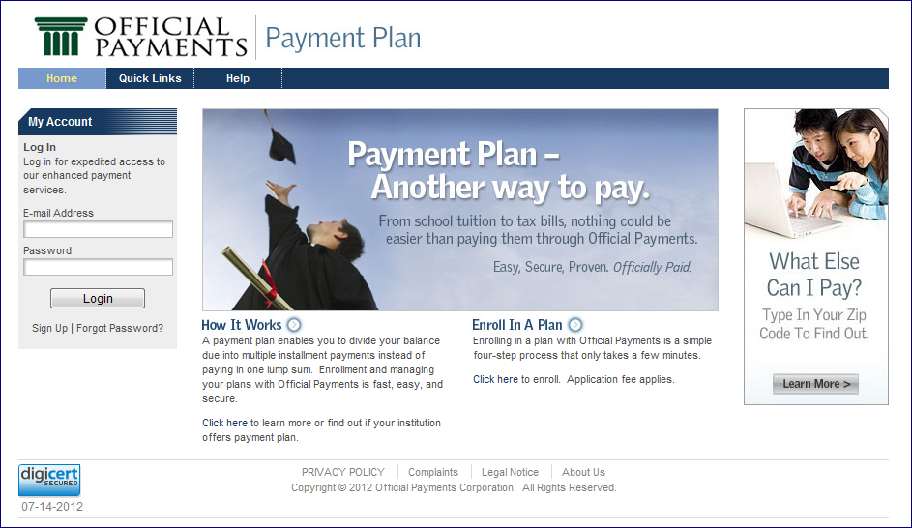

On this page, the user can:
- Click the Enroll in a Plan link or the Click here link in the paragraph below to begin enrolling in a plan.
- Click the How it Works link or the Click here link in the paragraph below to view how to enroll in a payment plan.

Select a Plan

Selecting an Entity
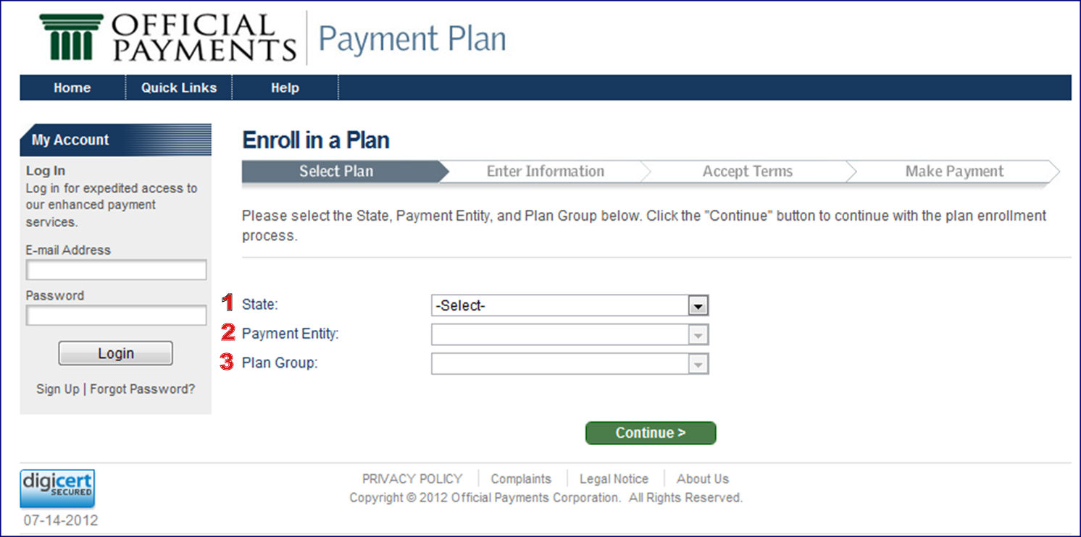

On the Select Entity page:
- Select the:
  - State - FLORIDA
Note: You will not be able to select a Payment Entity or Plan Group until a State is selected.
  - Payment Entity – Saint Leo University
  - Plan Group – Tuition and Fees
Note: You will not be able to select a Plan Group until a Payment Entity is selected.
- Click the Continue button to continue with the plan enrollment process.
- You will be directed to the Select Plan page.

Selecting a Plan
On the Select Plan page:
- Enter your 7-digit student ID number.
- Click the Search button.
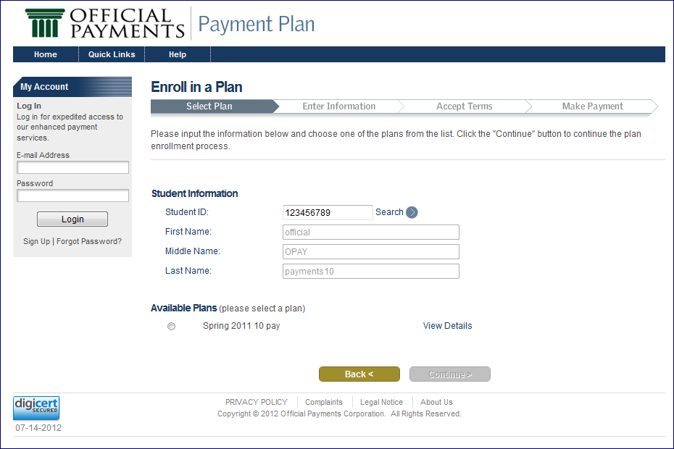

- Your information should be filled in automatically.
    - Note: There is a delay in the payment plan system and your registration. Please allow up to 48 business after registration to allow time for your payment plan options to be set up.
- The Plan List will display the plans that meet your eligibility.
- Select a plan.
Note: You are able to view/hide the details of the listed plans by expanding/collapsing each listed plan by using its View Details/Hide Details link.
- Click the Continue button to continue to the Amount page.
Note: If you need to return to the Select Entity page, click the Back button.

Accept Terms

Plan Acceptance
On the Plan Acceptance page, you are presented with your plan details and the Retail Installment Contract and Truth in Lending Disclosure, which you must electronically sign to continue the plan enrollment.
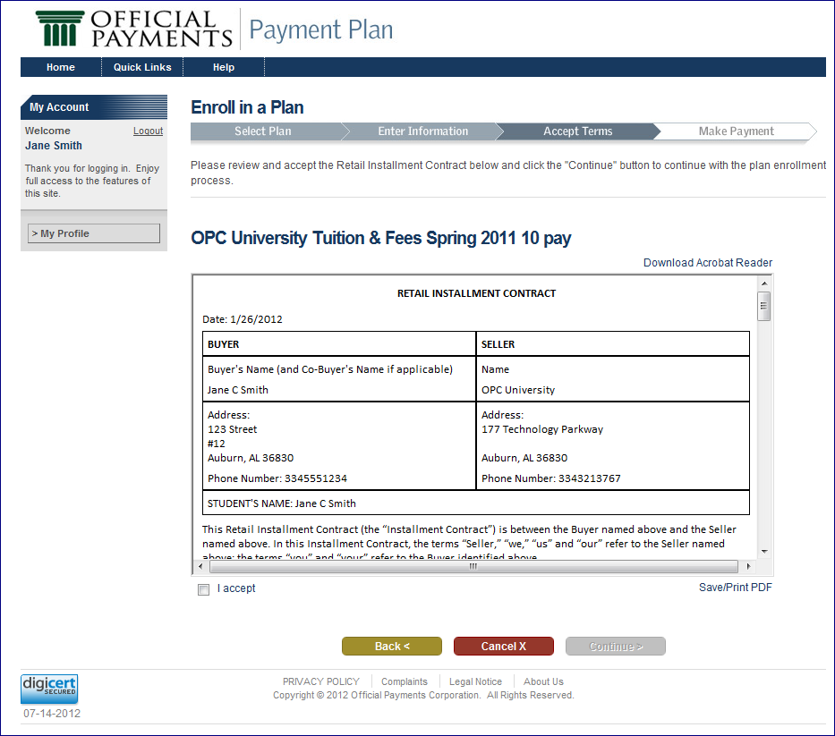

On the Plan Acceptance page, you must:
- Review the Retail Installment Contract and Truth in Lending Disclosure.
Note: You can click the Save/Print PDF link to open the contract in PDF format. You can then print or save it.
- Accept the Retail Installment Contract and Truth in Lending Disclosure by selecting the I accept check box at the bottom of the contract.

- Click the Continue button to continue with the plan enrollment.
If… | Then…
You previously selected that you would like to schedule automatic payments | You are directed to the Schedule Payment page. (See Chapter 8)
You DID NOT previously select that you would like to schedule automatic payments | You are directed to the Make Payment page.

Note: Click the Back button to return to the Amount page.
Note: If you wish to cancel the plan enrollment, click the Cancel button. You will be redirected to the Select Entity page.

Make Payment

Make Payment
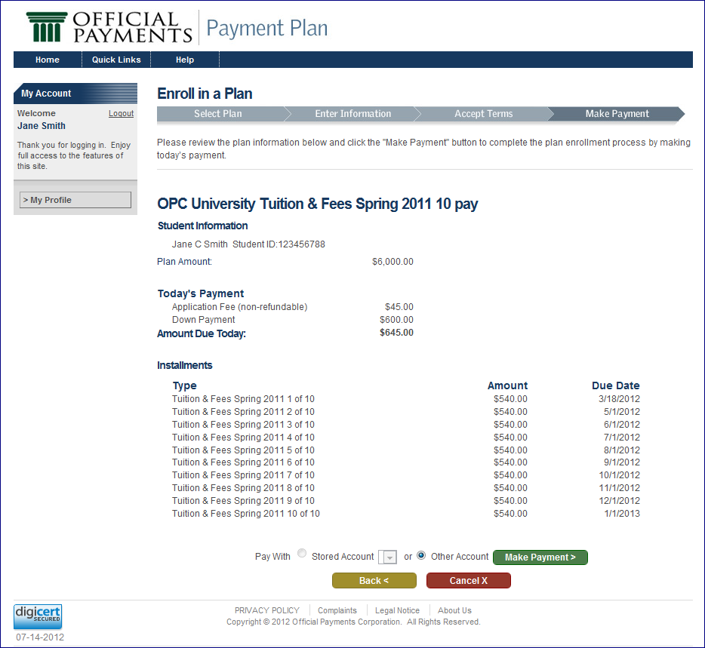

On the Make Payment page:
- Review the plan information. This includes:
  - Plan description
  - User information
  - Today’s amount due and future installments information
- Select whether you wish to pay with a Stored Account or another account (Other Account).

- Click the Make Payment button to complete the plan enrollment and payment process.
Note: Your plan status will be set to Pending, and you will be directed to the payment application to pay for the item(s) in Today’s Payment.
Note: Click the Back button to return to the Plan Acceptance page.
Note: If you wish to cancel the plan enrollment, click the Cancel button. You will be redirected to the Select Entity page.

Select Payment Method
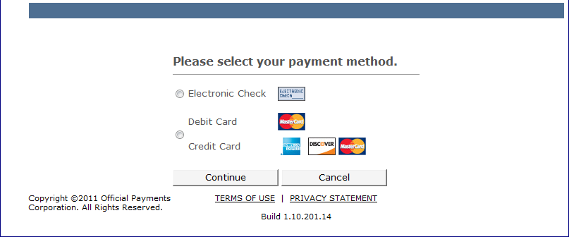

On the Select Payment Method page:
- Select Electronic Check or Debit Card/Credit Card.
- Click the Continue button.

Enter Payment Information
You can access the Payment page from either the enrollment process or the My Plans page.
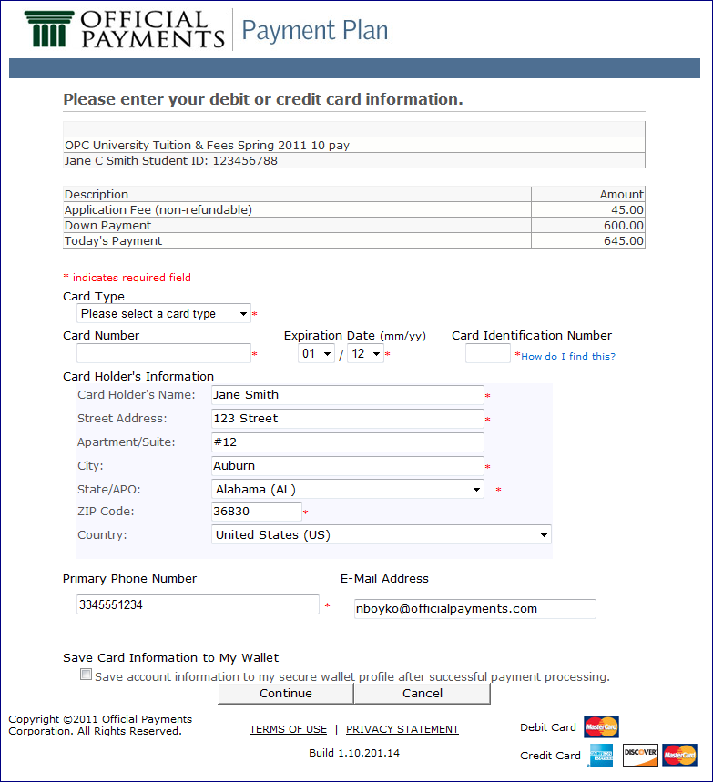

On the Enter Payment Information page:
- Enter the following information:
  - Card Type
  - Card Number
  - Expiration Date
  - Card Identification Number
Note: The Card Holder’s Name, Address, Phone Number, and E-Mail Address are populated from the My Account profile.
- Click the Save Card Information to My Wallet checkbox if you wish to save this information to your E-Wallet.
- Click the Continue button.

Verify Payment Information
On the Verify Payment Information page:
- Verify the items and amounts to be included in the payment.
- Click the Make Payment button.
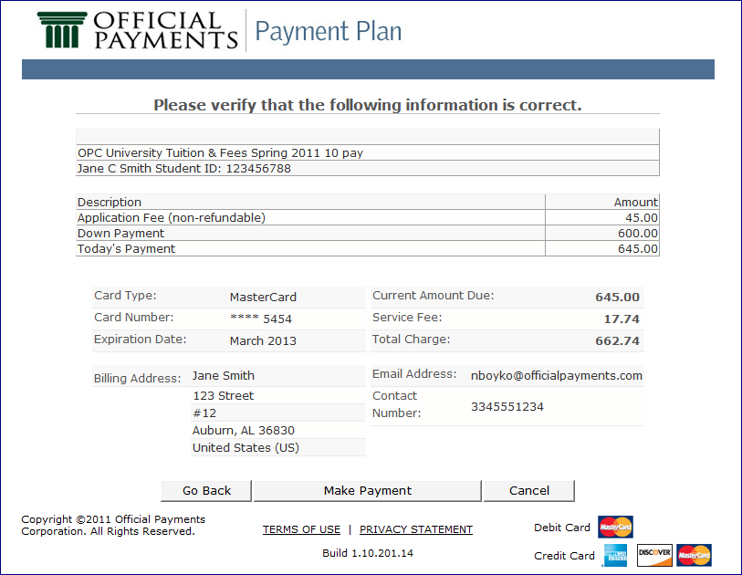
- Review the Confirmation of Payment.
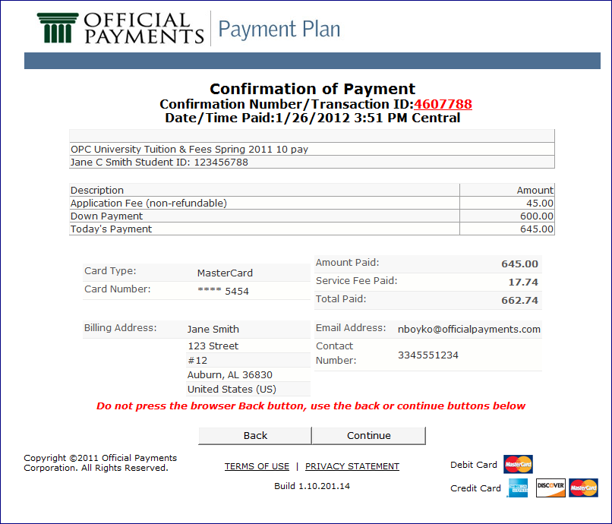

- Click the Continue button.
- You will return to the Home page, where you will have access to manage your plans and account.

Sign Up for My Account
Before you are able to finalize your plan enrollment, you must sign up for My Account. Click the Sign Up link on the My Account panel at any time.
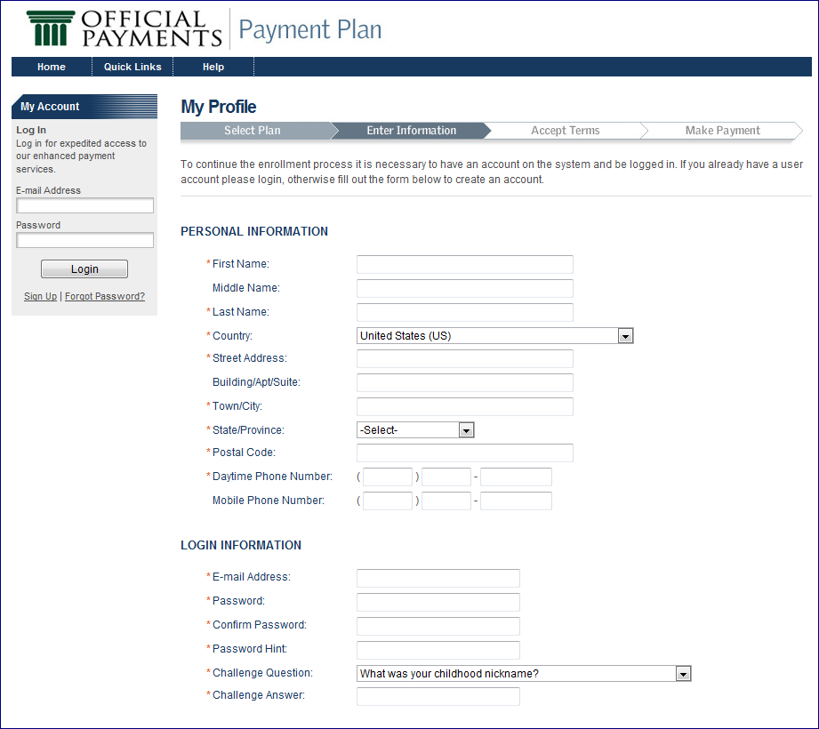
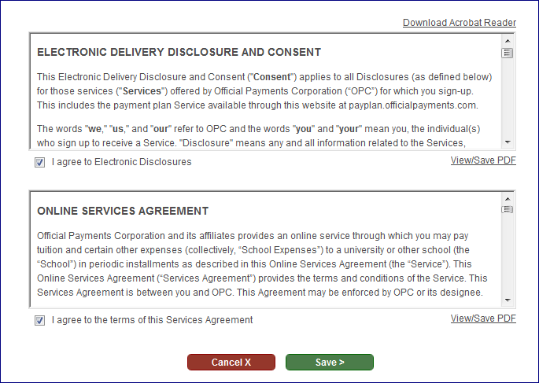

Use the following steps to complete the Sign Up page:
- Enter the:
  - E-mail Address
  - Password
  - Password Hint
  - Challenge Question
  - Challenge Answer
  - Name
  - Address
  - Phone
- Read and sign the Electronic Delivery Disclosure and Consent by clicking the I Agree to Electronic Disclosures checkbox.
- Read and sign the Online Services Agreement by clicking the I Agree to the Terms of this Services Agreement checkbox.
- Click the Save button.
Note: Your account will be authenticated. The My Account panel and buttons will display. You will be sent a Welcome e-mail acknowledging your new My Account.

Logging in to My Account
If you have My Account, use the following steps to log in to your account:
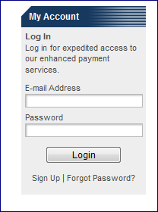

- Enter your E-mail Address.
- Enter your Password.
- Click the Login button.

Forgotten Password
If you forget your password, you will be able to receive a password hint or have it reset to a temporary password after answering a challenge question.
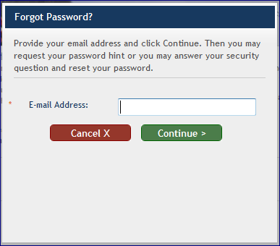

- Click the Forgot Password link on the My Account panel.
- Enter your E-mail Address.
- Click the Continue button.
Note: Clicking the Cancel button will discontinue this process.
- If your e-mail address is found, you will see the Email my password hint and Reset my password radio buttons.
- Select Email my password hint and click the Continue button to see a hint about your password. You can then try to log in to My Account.
- Select Reset my password and answer the challenge question before clicking the Continue button to get a new, temporary, password via e-mail. On your next successful login, you will be prompted to create a new password.

Managing Your Account

Viewing and Updating My Profile
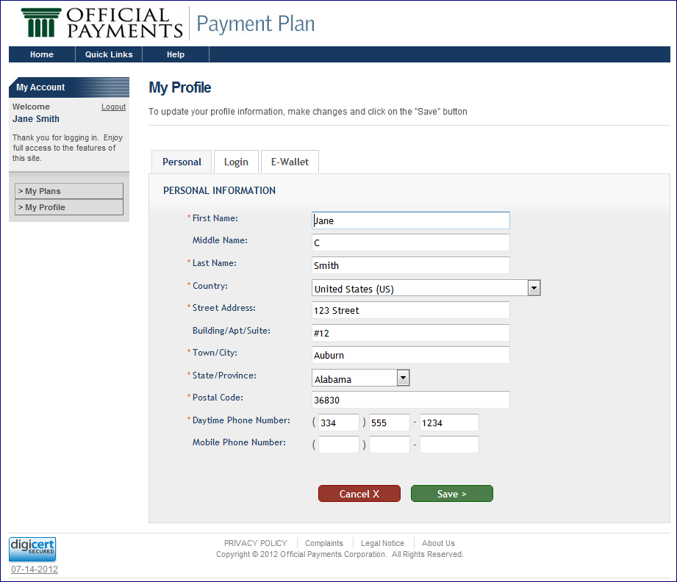

Updating Login Info
After logging in to the website, you have the option of editing your Personal information. Click the My Profile button. Make your edits, and click the Save button.
Note: Clicking the Cancel button will prevent changes from being made.
From the My Profile page, you can also:
- Update your Login information
- Update your E-Wallet information

Updating Login Info
From the My Profile page, you are able to access and update your Login information. To do this, just click the Login tab.
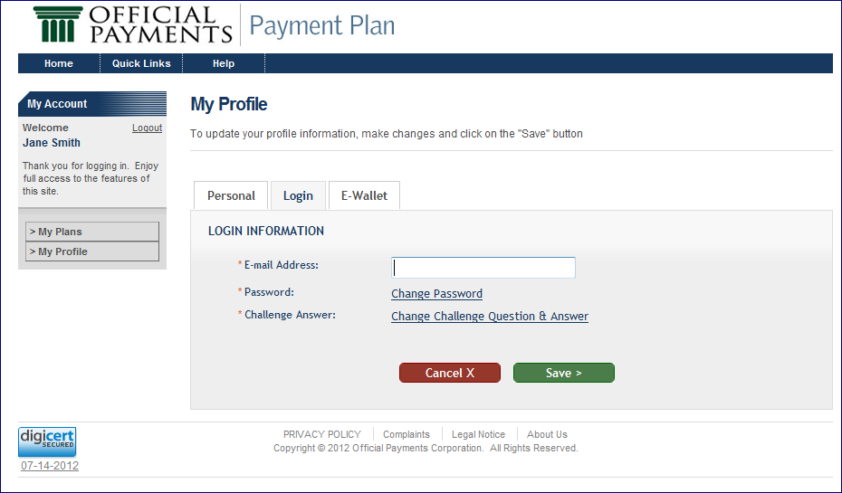

On the Login tab, you can update your:
- E-mail address
- Password
- Challenge Answer

Updating the E-mail Address
- Type your e-mail address in the appropriate text box.
- Click the Save button.

Updating the Password
- Click the Change Password link.
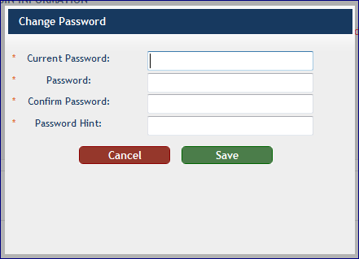

- Enter your:
  - Current Password
  - New Password
  - Confirm Password
  - Password Hint
- Click the Save button.

Updating the Challenge Question
- Click the Change Challenge Question & Answer link.
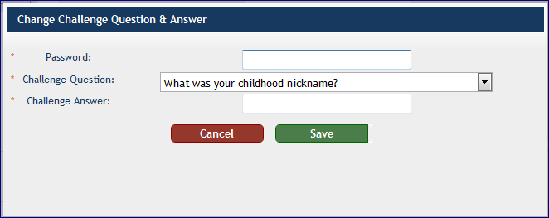

- Enter your:
  - Password
  - Challenge Question
  - Challenge Answer
- Click the Save button.

Updating E-Wallet Info
The E-Wallet tab on the My Profile page allows you to add or edit a financial account. You may access this page from the My Profile page.
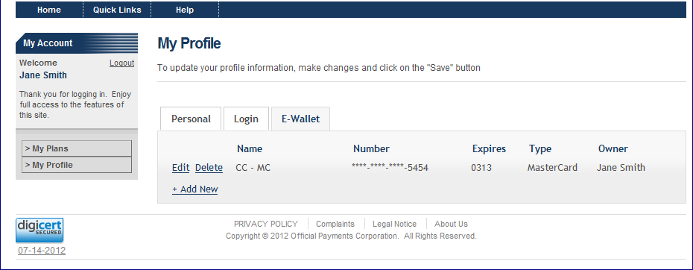

The E-Wallet tab displays a row for each of your financial account, with the following informational columns defined:
- Name
- Number
- Expiration Date
- Type
- Owner

Editing an E-Wallet Account
- Click the Edit link next to the account you wish to edit.
You will be directed to the payment application’s wallet maintenance page to edit the financial account.
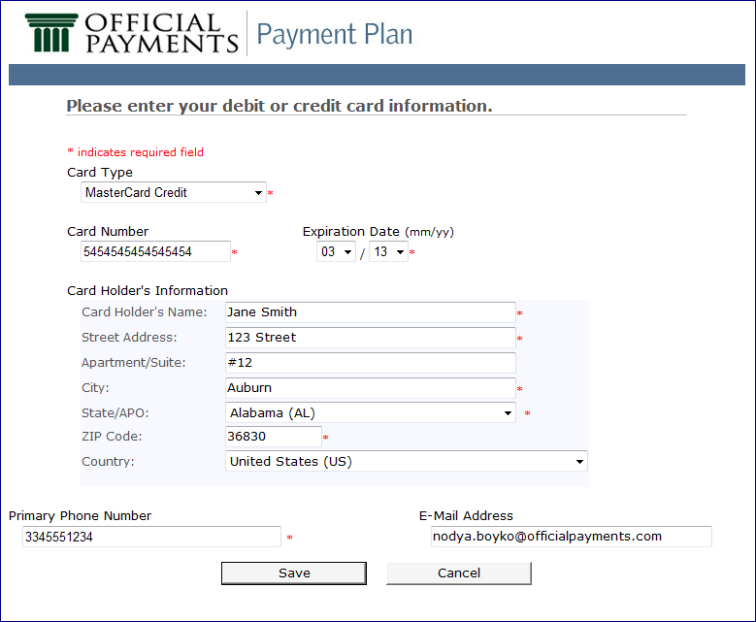

- Enter the necessary updates.
- Click the Save button.

To Add a Wallet Account
- Click the Add link.
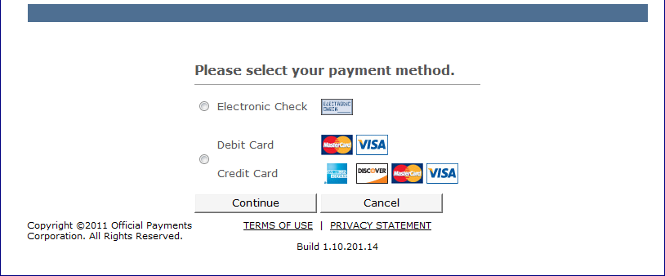

- Select either:
  - Electronic Check
  - Debit Card/Credit Card
- Click the Continue button.
If you select Debit or Credit Card, you will see a page similar to the following:

If you select Electronic Check, you will see the following:
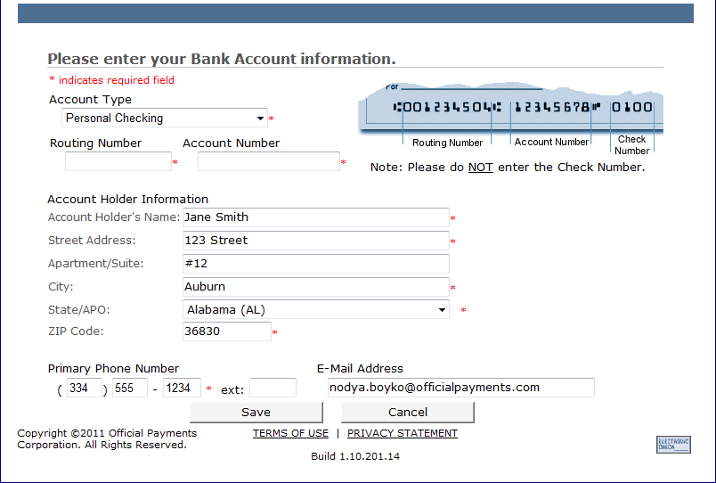

- Enter the necessary information.
- Click the Save button.

Viewing and Updating My Plans
On the My Plans page, you may view your current plans’ information and all plans you have previously enrolled.
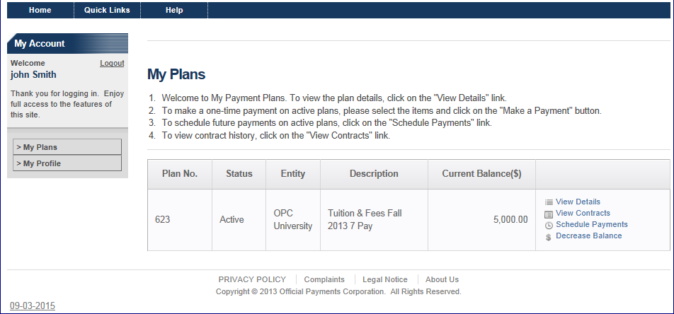
To do these things, you must first access the My Plans page by clicking the My Plans button that is on the My Account panel.
On the My Plans page you can:
- View your current and previously enrolled plans.
Note: The list of plans is constructed from all the plans you have enrolled in whose status is not pending or canceled.
- View the status of your plans. The possible statuses are:
Status | Definition
Active | The user has completed the enrollment plan acceptance step and made the payment, and the Last Payment Accepted Date has not passed.
OptedOut | If the user calls and requests to opt-out of one of his or her plans
Deactivated | When the user has exceeded Allowed Past Due Installments, he or she may not perform any action on the plan. A plan whose status is Deactivated may be changed to Reactivate by Official Payments Customer Service Representative once.
Incomplete | During Ended Plans processing: If the plan is on the Last Payment Accepted Date, and all payable items are not paid, but the user has NOT exceeded Allowed Past Due Installments, the status of his or her instance of the plan will be changed to Incomplete and he or she will be sent the Incomplete Plan notification.
Reactivate | The user may not perform any action on his or her plan. The system will set the status to Active during the next normal cycle of the system processes.
Complete | This is on the Last Payment Accepted Date when all payable items are paid.
Terminated | This is on the Last Payment Accepted Date when all payable items are not paid, or when the user has exceeded the Allowed Past Due Installments on a plan that has previously been reactivated.

- Click on the View Details link to view the plan details.
Note: Click Hide Details to hide the plan details.
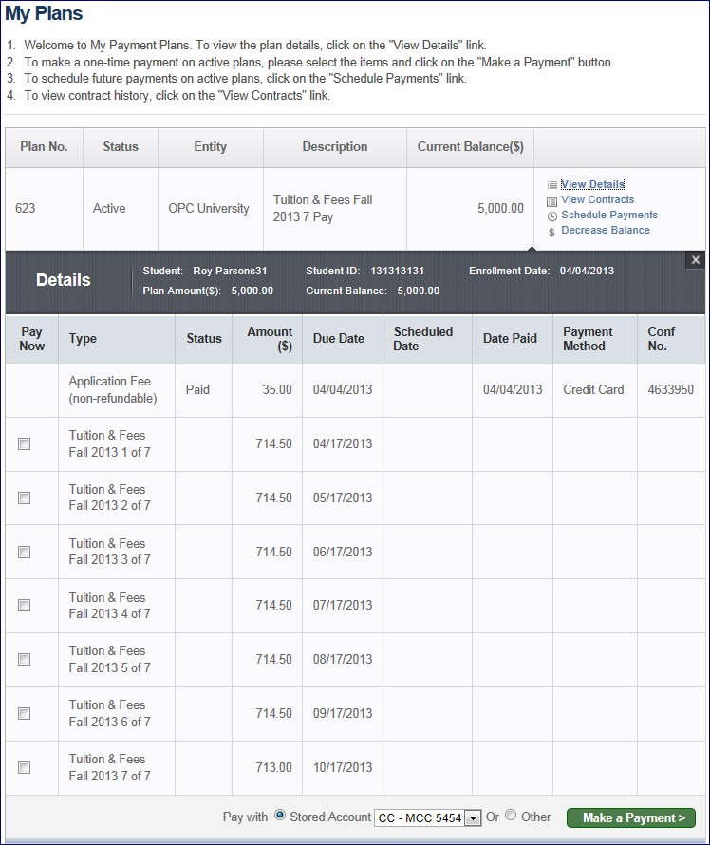

- From a plan’s Details, you can make a one-time payment on an active plan by selecting the desired items’ Pay Now checkbox and clicking the Make a Payment button.
Note: Clicking the Make a Payment button directs you to the payment application to pay for the plan’s checked items.
- Schedule future payments on an active plan by clicking the Schedule Payments link.
Note: Clicking the Schedule Payments link redirects you to the Schedule Payments page.
- Click the View Contracts link to view contracts.
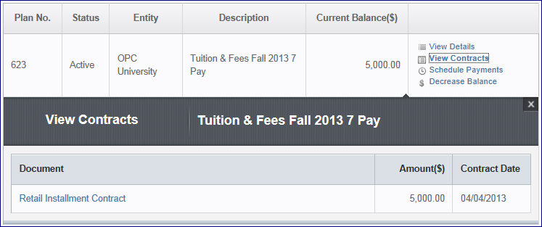

Note: Click the link of the contract document you wish to review. When the contract details display, you have the option to View/Save the PDF on your desktop. When finished reviewing the details of the contract, you can click Close.
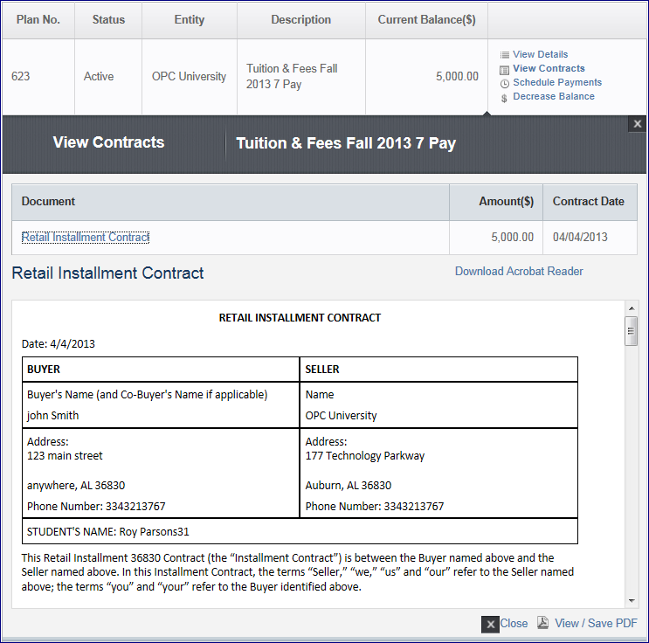
- Click the Adjust Balance link to decrease your account balance.
Note: The link will say Adjust Balance if the student can increase or decrease their balance. It will say Increase Balance if they can only increase their balance. It will say Decrease Balance if the only option is to decrease their balance.
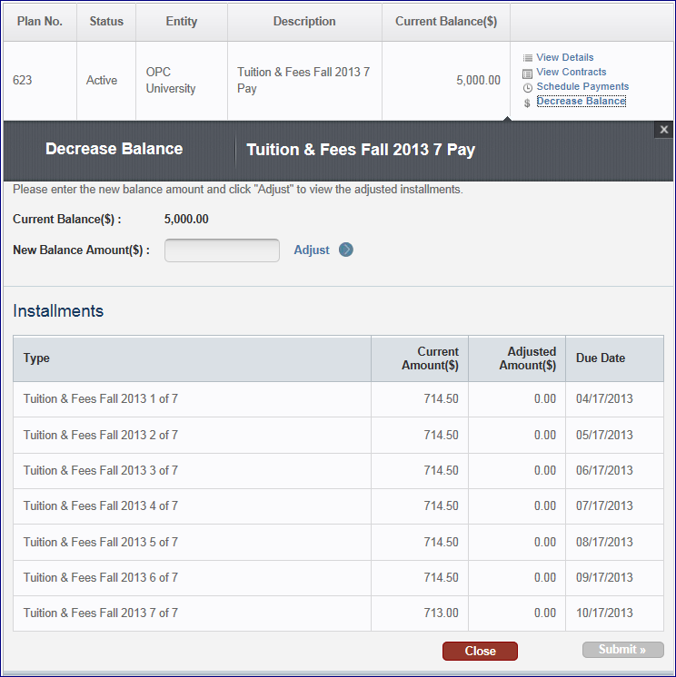

Note: Enter the New Balance Amount and click the Adjust button. When ready, click the Submit button. The Addendum to Retail Installment Contract displays. You can save this to your desktop. When finished viewing, click the Close button.

Schedule Payments

Scheduling Payment Installments
Scheduling Payment Installments allows you to set the dates for payments to be automatically made on your behalf.
Note: You must be logged in and have a plan selected to access this page. You can access this page from the My Plans page upon clicking a plan’s Schedule Payments link.
Note: You can also access this page if you checked the “I would like to schedule automatic payments for my plan installments” checkbox during the plan enrollment process.
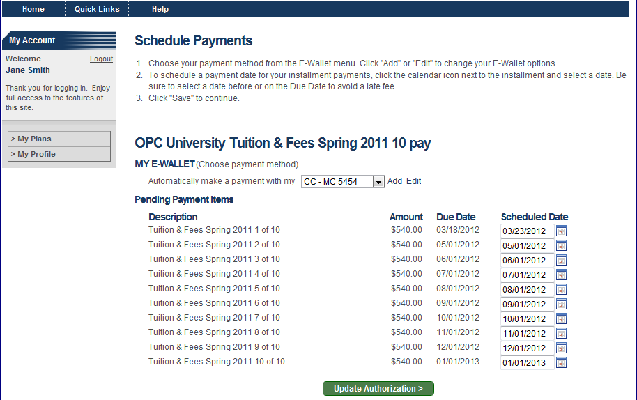
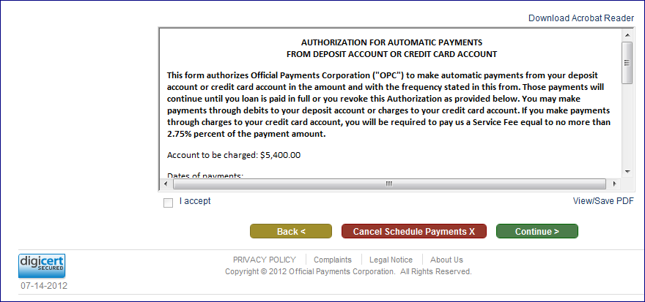
To schedule payments, use the following steps:
- Review the Plan Description at the top of the page.
- Add/Select a wallet payment option.
Note: For your installments to be paid automatically, you must save a financial account that the payments will be made from, and you must schedule the date for each payable item.
Note: Any wallet account you have previously saved will be listed in the e-wallet dropdown. Any wallet account of a type not accepted by the plan will be disabled.
Note: If you need to add or edit your wallet account, click the Add link or the Edit link. Once your changes are made, you’ll be redirected to this page to continue scheduling payment installments.
- Select the payment date for each item.
Note: If installments are scheduled after the due date, fees may be assessed.
Note: Click the I understand button in the popup to proceed if you are scheduling payments after the due date.
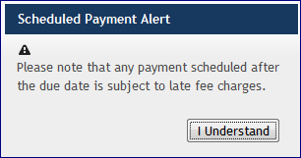

- Read the Authorization for Automatic Payments.
- Click the I Accept checkbox.
Note: You must sign this authorization every time you edit your scheduled payments. To print or save the authorization, click the View/Save PDF link.
- Click the Save button. This will redirect you to the Make Payment or My Plans page, depending on your point of origin.
Note: You cannot Save your scheduled payment if you have not selected a wallet account.
Note: If you click the Back button, you will be redirected to the Plan Acceptance page if you were in the plan enrollment process, or the My Plans page, if that was your origin.
Note: If you click the Cancel Scheduling button, you will be directed to the My Plans page.

E-Mail Notifications
As you enroll in Payment Plan and as you update your account, you will be sent e-mail notifications. You will generally receive an e-mail when you:
- Create a Payment Plan Account
- Enroll in a Payment Plan
- Make a Payment
- Schedule a Payment
- Are Due to Make a Payment
- Update your Account Profile
- Assess a Fee on your Payment Plan
- Alter your Login Information
You will also receive an e-mail when your:
- Payment Plan Balance is Adjusted
- Payment Plan has been Terminated
- Payment Plan has been Deactivated
- Credit Card is due to Expire

Your Account Has Been Created
After creating a Payment Plan Account, you will receive an e-mail notification, as follows:
Thank you for creating an account with Official Payments. My Account enables you to easily manage your payment plan to:
  - make a one-time payment
  - schedule future payments
  - make updates to scheduled payments
  - view your Payment Plan details and summary information
Thank you for using Official Payments. We look forward to serving you.
Sincerely,
Official Payments Customer Service
PPlanService@OfficialPayments.com
This e-mail is auto-generated by the system. Please do not reply to this email. If you have any questions, e-mail us at customerservice@officialpayments.com.
Official Payments is the leading provider of electronic payment solutions for the IRS, 27 states, the District of Columbia and more than 4200 clients in all 50 states. We accept payments for taxes, rent, utilities, education and more. Learn more by visiting https://www.officialpayments.com/pc_whocanipay.jsp

Payment Plan Enrollment Confirmation
After you have enrolled in a Payment Plan, you will receive an e-mail notification, as follows:
Thank you for your payment plan enrollment for OPC University.
Plan Information
******************************************
Plan: Tuition & Fees Spring 2011 10 pay Enrollment Date: 01/26/2012 Plan Amount: 6,000.00
Student ID: 123456787
Payment Schedule
******************************************
03/18/2012 540.00
05/01/2012 540.00
06/01/2012 540.00
07/01/2012 540.00
08/01/2012 540.00
09/01/2012 540.00
10/01/2012 540.00
11/01/2012 540.00
12/01/2012 540.00
01/01/2013 540.00
Please review this information for accuracy and let us know if there are any issues as soon as possible as refunds will only be initiated due to a processing error.
Thank you for using Official Payments. We look forward to serving you.
Sincerely,
Official Payments Customer Service
PPlanService@OfficialPayments.com
This e-mail is auto-generated by the system. Please do not reply to this email. If you have any questions, e-mail us at customerservice@officialpayments.com.
Official Payments is the leading provider of electronic payment solutions for the IRS, 27 states, the District of Columbia and more than 4200 clients in all 50 states. We accept payments for taxes, rent, utilities, education and more. Learn more by visiting https://www.officialpayments.com/pc_whocanipay.jsp

Your Payment Confirmation
You will be sent the Payment Confirmation notification any time a Payment Plan payment is made on your plan. You will receive an e-mail notification, as follows:
Thank you for your payment for OPC University's Tuition & Fees Spring 2011 plan.
Payment Information
******************************************
Confirmation Number: 4607791
Date: 01/26/2012
Credit Card
123 Street
Auburn
AL 36830

Student ID: 123456787
01/26/2012 45.00 Application Fee (non-refundable)
01/26/2012 600.00 Down Payment

Payment Amount: 645.00
Service Fee: 17.74
Total Amount: 662.74
Please review this information for accuracy and let us know if there are any issues as soon as possible as refunds will only be initiated due to a processing error.
Thank you for using Official Payments. We look forward to serving you.
Sincerely,
Official Payments Customer Service
PPlanService@OfficialPayments.com
Official Payments is the leading provider of electronic payment solutions for the IRS, 27 states, the District of Columbia and more than 4200 clients in all 50 states. We accept payments for taxes, rent, utilities, education and more. Learn more by visiting https://www.officialpayments.com/pc_whocanipay.jsp

Your Payment has been Scheduled
When you have scheduled a payment, you will receive an e-mail notification, as follows:
This is a reminder that your automatic payment will be made on 02/01/2012 for OPC University Tuition and Fees Fall 2011 plan.
Payment Information
******************************************
Date: 02/01/2012
Credit Card 5454
OfficialPaytest@hotmail.com
177 Technology Parkway
Auburn AL 36830
Student ID: 121212121
02/01/2012 1,250.00 Tuition and Fees Fall 2011 3 of 4
Payment Amount: 1,250.00
Service Fee: 34.38
Total Amount: 1,284.38
Please review this information for accuracy and let us know if there are any issues as soon as possible as refunds will only be initiated due to a processing error.
Please note that scheduling a future payment may not avoid fees if it is scheduled past the due date.
Thank you for using Official Payments. We look forward to serving you.
Sincerely,
Official Payments Customer Service
PPlanService@OfficialPayments.com
Official Payments is the leading provider of electronic payment solutions for the IRS, 27 states, the District of Columbia and more than 4200 clients in all 50 states. We accept payments for taxes, rent, utilities, education and more. Learn more by visiting: https://www.officialpayments.com/pc_whocanipay.jsp

Your Payment Plan Payment is Due Soon
When your payment is nearing its due date, you will receive an e-mail notification, as follows:
This is a reminder that your next payment is due on 02/01/2012 for OPC University's payment plan. Please login to My Account to make the payment.
This payment is for
Plan: Tuition & Fees Spring 2011 3 Pay
Student ID: 111119999
02/01/2012 1,667.00 Tuition & Fees Spring 2011 3 of 3
Payment Amount: 1,667.00
Thank you for using Official Payments. We look forward to serving you.
Sincerely,
Official Payments Customer Service
PPlanService@OfficialPayments.com
This e-mail is auto-generated by the system. Please do not reply to this email. If you have any questions, e-mail us at customerservice@officialpayments.com.
Official Payments is the leading provider of electronic payment solutions for the IRS, 27 states, the District of Columbia and more than 4200 clients in all 50 states. We accept payments for taxes, rent, utilities, education and more. Learn more by visiting: https://www.officialpayments.com/pc_whocanipay.jsp

Important Notice: Fee Assessed on your Payment Plan
If you are late in making a payment, you will accrue a fee. When this happens, you will receive an e-mail notification, as follows:
A Late Fee in the amount of 20.00 assessed on OPC University's payment plan.
Plan: Tuition & Fees Spring 2011 3 Pay
Student ID: 333444555
If you have scheduled your payments, this fee may be added to a future payment. Please bring your account up to date by logging into My Account before your next payment.
Unpaid fees may lead to deactivation of your plan and may cause future plan enrollment applications to be rejected.
Thank you for using Official Payments. We look forward to serving you.
Sincerely,
Official Payments Customer Service
PPlanService@OfficialPayments.com
This e-mail is auto-generated by the system. Please do not reply to this email. If you have any questions, e-mail us at customerservice@officialpayments.com.
Official Payments is the leading provider of electronic payment solutions for the IRS, 27 states, the District of Columbia and more than 4200 clients in all 50 states. We accept payments for taxes, rent, utilities, education and more. Learn more by visiting: https://www.officialpayments.com/pc_whocanipay.jsp
If your payment is returned, you will accrue a fee. When this happens, you will receive an e-mail notification, as follows:
A Returned Payment Fee in the amount of 75.00 assessed on Herndon University's payment plan.
Plan: OPC University Fall 2011 5 Pay External Account ID: 45046
If you have scheduled your payments, this fee may be added to a future payment. Please bring your account up to date by logging into My Account before your next payment.
Unpaid fees may lead to deactivation of your plan and may cause future plan enrollment applications to be rejected.
Thank you for using Official Payments. We look forward to serving you.
Sincerely,
Official Payments Customer Service
PPlanService@OfficialPayments.com
This e-mail is auto-generated by the system. Please do not reply to this email. If you have any questions, e-mail us at customerservice@officialpayments.com.
Official Payments is the leading provider of electronic payment solutions for the IRS, 27 states, the District of Columbia and more than 4200 clients in all 50 states. We accept payments for taxes, rent, utilities, education and more. Learn more by visiting https://www.officialpayments.com/pc_whocanipay.jsp

Your Account Profile Has Been Updated
After updating your account profile, you will receive an e-mail notification, as follows:
If you did not recently update your profile, please contact Official Payments as soon as possible.
Thank you for helping us keep your information safe and secure.
Sincerely,
Official Payments Customer Service
PPlanService@OfficialPayments.com
This e-mail is auto-generated by the system. Please do not reply to this email. If you have any questions, e-mail us at customerservice@officialpayments.com.
Official Payments is the leading provider of electronic payment solutions for the IRS, 27 states, the District of Columbia and more than 4200 clients in all 50 states. We accept payments for taxes, rent, utilities, education and more. Learn more by visiting https://www.officialpayments.com/pc_whocanipay.jsp

Login Information
When you edit your login information (password or e-mail address), you will receive an e-mail notification, as follows:
Your password has temporarily been reset to zsAaI^*9iHWN
If you did not make this request, please contact Official Payments Customer Service as soon as possible. Thank you for helping us keep your information safe and secure.
Sincerely,
Official Payments Customer Service
PPlanService@OfficialPayments.com
Official Payments is the leading provider of electronic payment solutions for the IRS, 27 states, the District of Columbia and more than 4200 clients in all 50 states. We accept payments for taxes, rent, utilities, education and more. Learn more by visiting: https://www.officialpayments.com/pc_whocanipay.jsp

Payment Plan Balance Adjusted
When your Payment Plan Balance has been adjusted, you will receive an e-mail notification, as follows:
OPC University has adjusted your payment plan balance as follows:
Plan Information
******************************************
Plan: Tuition & Fees Spring 2012 7 pay
Student ID: xxxxxxx
Enrollment Date: 0X/XX/2012
Original Plan Amount: 2,975.00
Credit: 2,975.00
Balance as of Today: 445.13
Payment Schedule
*********************************************************************
Due Date Original Amount Adjusted Amount Item
*********************************************************************
05/01/2012 425.13 425.13 Tuition & Fees Spring 2012 1 of 7
05/12/2012 20.00 20.00 Late Fee - Installment 1
06/01/2012 425.13 0.00 Tuition & Fees Spring 2012 2 of 7
07/01/2012 425.13 0.00 Tuition & Fees Spring 2012 3 of 7
08/01/2012 425.13 0.00 Tuition & Fees Spring 2012 4 of 7
09/01/2012 425.13 0.00 Tuition & Fees Spring 2012 5 of 7
10/01/2012 425.13 0.00 Tuition & Fees Spring 2012 6 of 7
11/01/2012 424.22 0.00 Tuition & Fees Spring 2012 7 of 7
If you have any questions, please contact OPC University as soon as possible.
Thank you for using Official Payments. We look forward to serving you.
Sincerely,
Official Payments Customer Service
customerservice@OfficialPayments.com
This e-mail is auto-generated by the system. Please do not reply to this email. If you have any questions, e-mail us at customerservice@officialpayments.com.
Official Payments is the leading provider of electronic payment solutions for the IRS, 27 states, the District of Columbia and more than 4200 clients in all 50 states. We accept payments for taxes, rent, utilities, education and more. Learn more by visiting https://www.officialpayments.com/pc_whocanipay.jsp
This e-mail message and any attachments are intended only for the use of the addressee named above and may contain information that is proprietary and confidential. If you are not the intended recipient, any dissemination, distribution, or copying is strictly prohibited. If you received this email message in error, please immediately notify the sender by replying to this e-mail message or by telephone. Thank you.

Payment Plan is Terminated
When your Payment Plan is terminated, you will receive an e-mail notification, as follows:
Your participation in the Payment Plan below has ended because the plan is terminated.

Plan: dining Fall Fall 5 pay
Student ID: xxxxxxxxx

02/01/2012 1,000.00 dining Fall 2 of 5
03/01/2012 1,000.00 dining Fall 3 of 5
04/01/2012 1,000.00 dining Fall 4 of 5
05/01/2012 1,000.00 dining Fall 5 of 5

Please contact xxxxxxx to make arrangements for making your outstanding payments.
Sincerely,
Official Payments Customer Service
customerservice@OfficialPayments.com
Official Payments is the leading provider of electronic payment solutions for the IRS, 27 states, the District of Columbia and more than 4200 clients in all 50 states. We accept payments for taxes, rent, utilities, education and more. Learn more by visiting https://www.officialpayments.com/pc_whocanipay.jsp
This email message and any attachments are intended only for the use of the addressee named above and may contain information that is proprietary and confidential. If you are not the intended recipient, any dissemination, distribution, or copying is strictly prohibited. If you received this email message in error, please immediately notify the sender by replying to this email message or by telephone. Thank you.

Payment Plan is Deactivated
When your Payment Plan is deactivated, you will receive an e-mail notification, as follows:
Your participation in the OPC University Payment Plan below has been deactivated due to exceeding the number of past due payments allowed.

Plan: Tuition & Fees Spring 2012 5 Pay
Student ID: xxxxxxxxxxxxxx

Please contact OPC University to make arrangements for making these payments.
Sincerely,
Official Payments Customer Service
customerservice@OfficialPayments.com

This e-mail is auto-generated by the system. Please do not reply to this email. If you have any questions, e-mail us at customerservice@officialpayments.com.
Official Payments is the leading provider of electronic payment solutions for the IRS, 27 states, the District of Columbia and more than 4200 clients in all 50 states. We accept payments for taxes, rent, utilities, education and more. Learn more by visiting https://www.officialpayments.com/pc_whocanipay.jsp
This email message and any attachments are intended only for the use of the addressee named above and may contain information that is proprietary and confidential. If you are not the intended recipient, any dissemination, distribution, or copying is strictly prohibited. If you received this email message in error, please immediately notify the sender by replying to this email message or by telephone. Thank you.

Credit Card Due to Expire
When your credit card is due to expire, you will receive an e-mail notification, as follows:
This is an important message regarding the credit card associated with TS_AG7's payment plan scheduled payments. This card is set to expire in the near future. To ensure that your service will not be interrupted, please take a moment to update your account profile.

Plan Information
******************************************
Plan: Fall 2014 Plan
TaxExtAcctID: XXXXXXXXXXXX
Joe User

Thank you for using Official Payments. We look forward to serving you.
Sincerely,
Official Payments Customer Service
PPlanService@OfficialPayments.com
This e-mail is auto-generated by the system. Please do not reply to this email. If you have any questions, e-mail us at customerservice@officialpayments.com.
Official Payments is the leading provider of electronic payment solutions for the IRS, 27 states, the District of Columbia and more than 4200 clients in all 50 states. We accept payments for taxes, rent, utilities, education and more. Learn more by visitinghttps://www.officialpayments.com/pc_whocanipay.jsp

